Security Test Cases – Automated Quality Assurance System
Project: Security in Software Engineering
- Authentication Tests
Test Case 1: Valid Login.
- Purpose: Verify that a registered user can log in successfully.
- Steps:
1. Open Postman.
2. Send POST request to /api/login with valid username and password.
- Expected Result: - Status code 200 OK. - Response contains a JWT token.
- Screenshot:
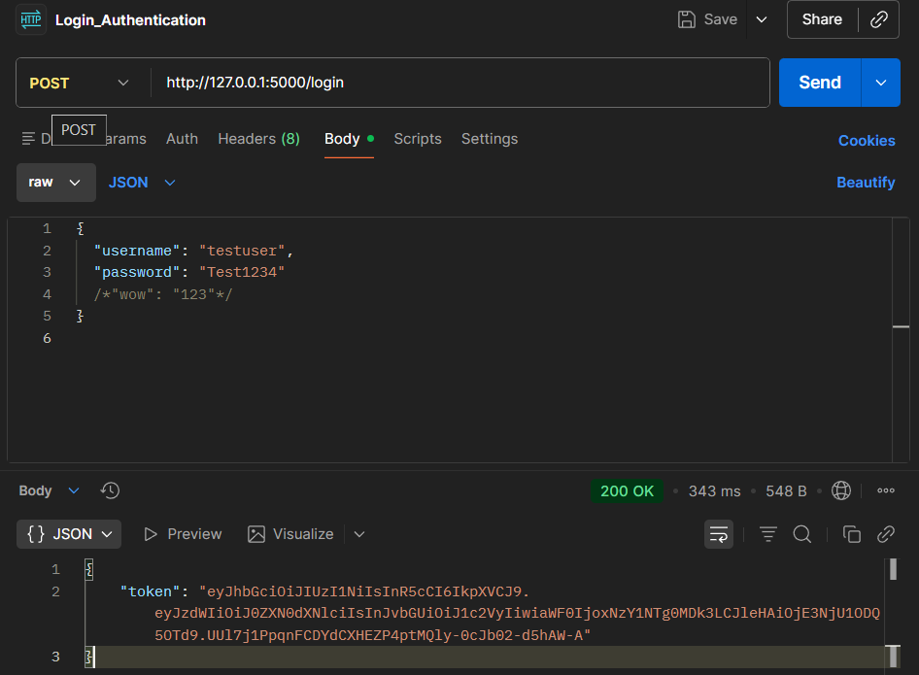
Test Case 2: Invalid Credentials
- Purpose: Ensure system rejects login with incorrect username or password.
- Steps:
1. Send POST request with wrong username/password.
- Expected Result: - Status code 401 Unauthorized. - Response: “Invalid credentials”.
- Screenshot:
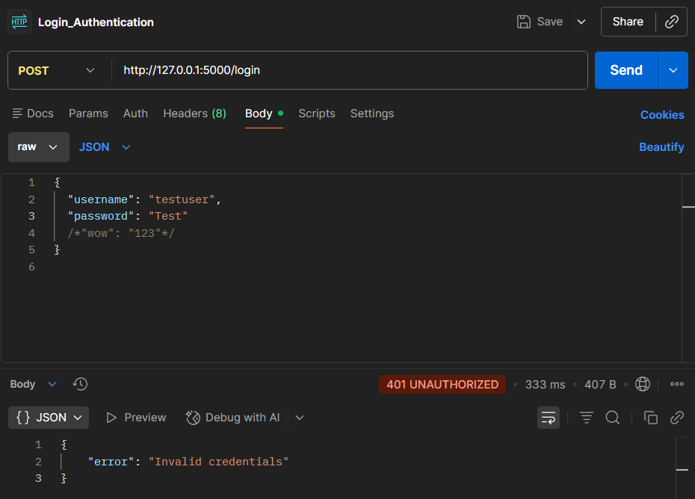
Test Case 3: Account Lockout
- Purpose: Verify account is locked after multiple failed login attempts.
- Steps:
1. Attempt login 6 times with wrong password.
- Expected Result: - Account locked for 30 seconds. - Response: “Account locked. Try later.”

- Screenshot:
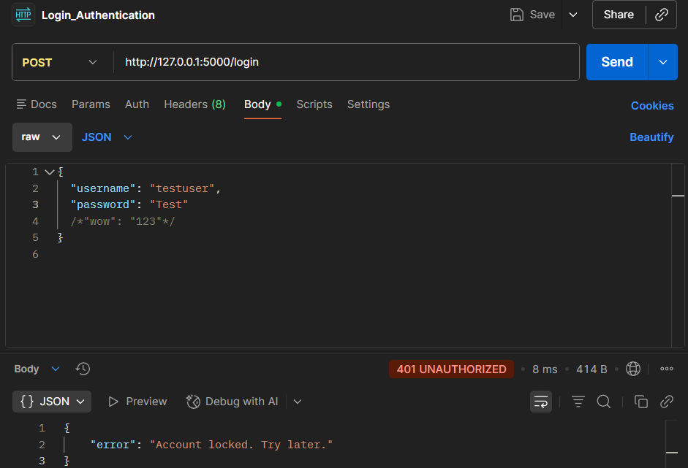
- Input Validation Tests
Test Case 4: Empty Username/Password
- Purpose: Ensure system handles empty inputs.
- Steps:
1. Send POST request with empty username or password.
- Expected Result: - Status code 400 Bad Request. - Response: “Username and password required” (or similar).

- Screenshot:
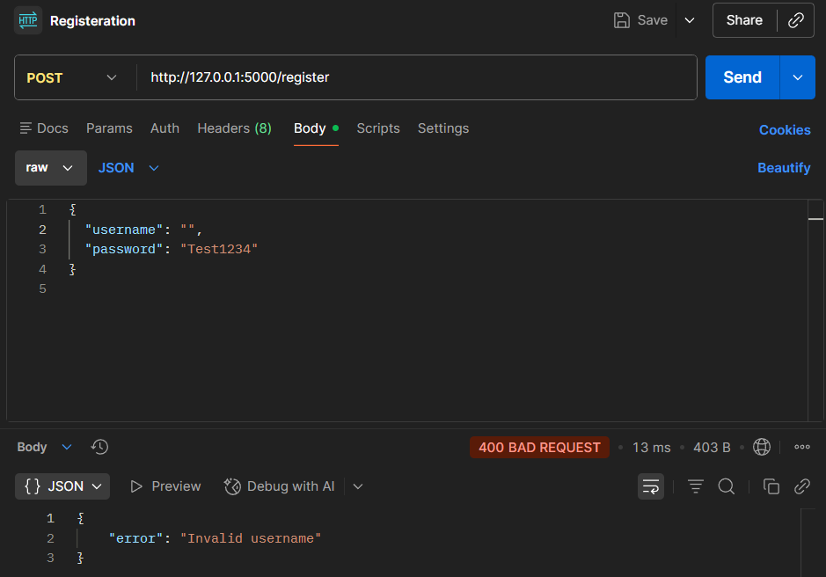
Test Case 5: Invalid Data Types
- Purpose: Ensure system rejects invalid input types (numbers instead of strings, etc.)
- Steps:
1. Send POST request with numeric username or special characters.
- Expected Result: - Proper error message returned.

– Screenshot:
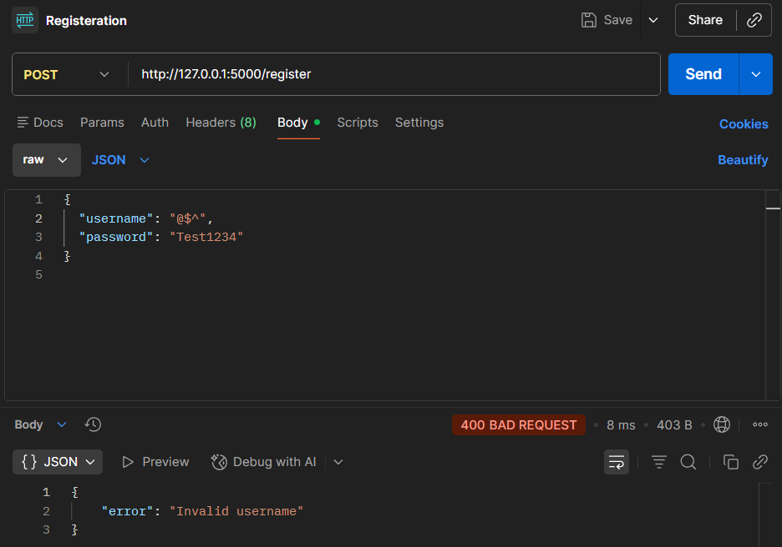
- Token/Encryption Tests
Test Case 6: Token Verification
- Purpose: Ensure JWT token can be decoded and verified.
- Steps:
1. Use returned JWT token from valid login.
2. Decode using public key.
- Expected Result: - Token payload matches user details (sub, role, iat, exp). - Token is valid.

- Screenshot:
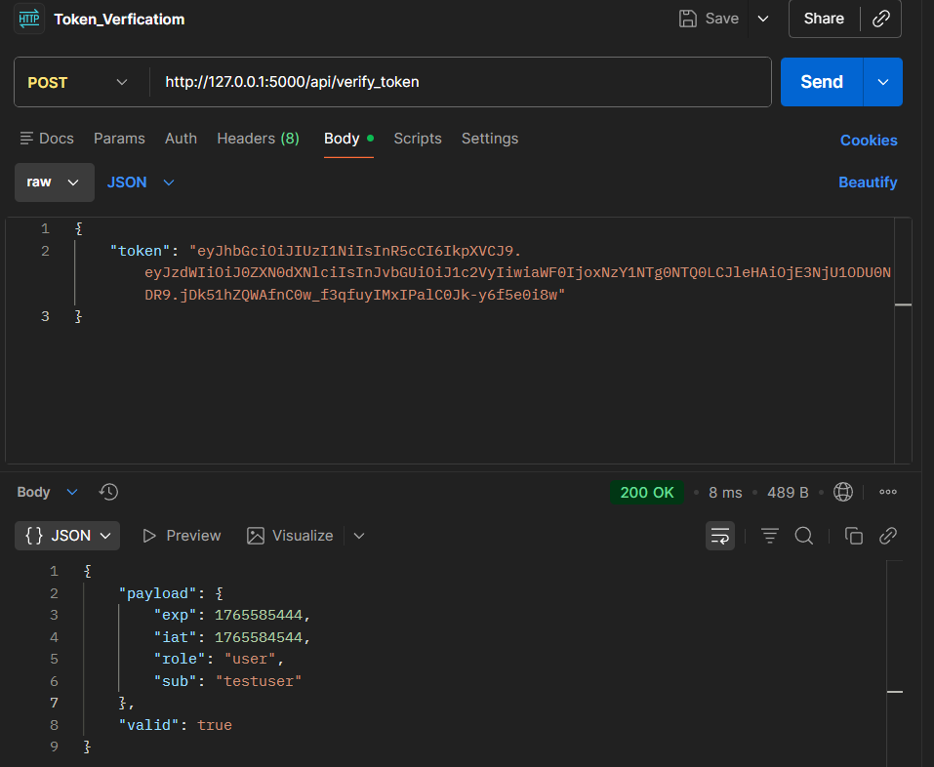
Test Case 7: Expired Token
- Purpose: Verify system rejects expired tokens.
- Steps:
1. Use JWT token after expiration.
- Expected Result: - Response: “Token expired” or equivalent.

- Screenshot:
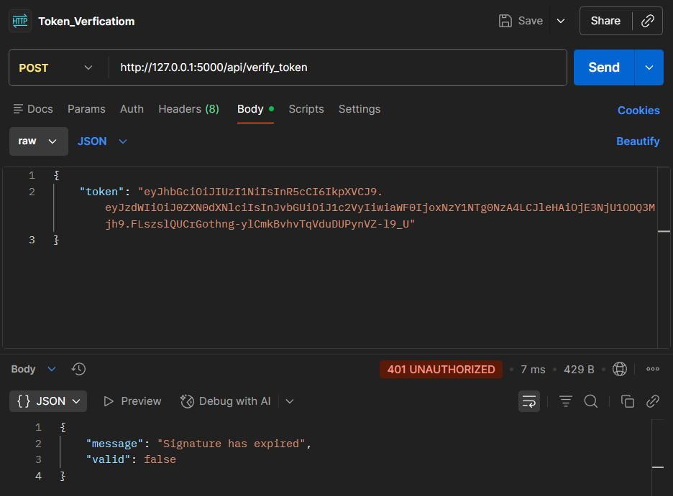
- Misuse Case Tests
Test Case 8: Invalid Token
- Purpose: Ensure system rejects tampered or invalid tokens.
- Steps:
1. Modify token or use random string.
2. Access protected endpoint.
- Expected Result: - Status code 401 Unauthorized. - Response: “Invalid token”

- Screenshot:
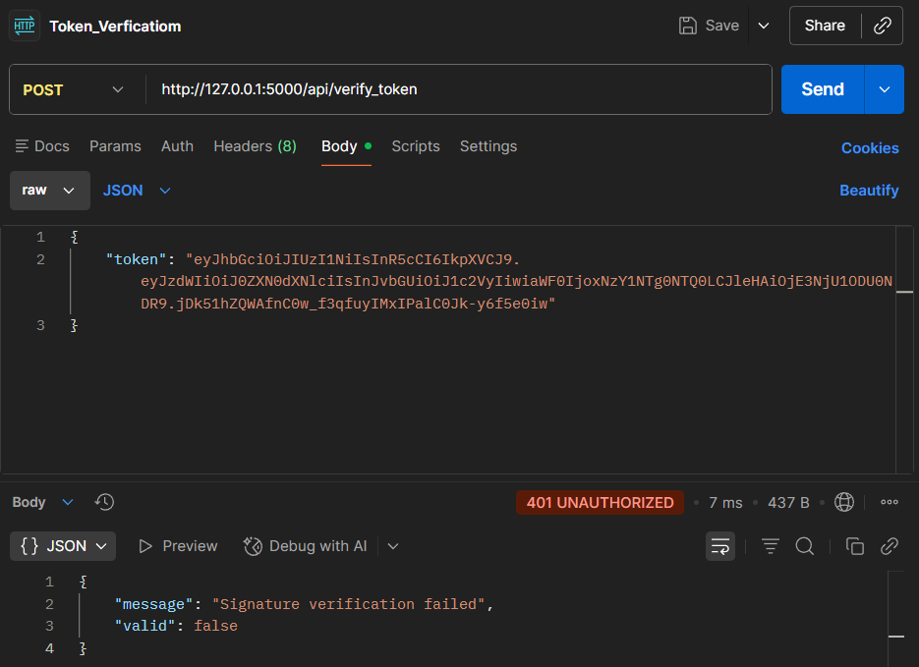

Submitted by:
Belal Elshazly 221007975
Omar Waleed 221017650

